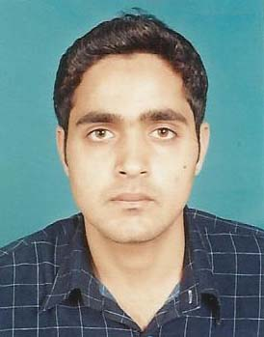


IRFAN TARIQ
Personal details

Date of Birth: | 09 | - | 03 |  | - |  | 1987
Address: | E 29/9 B Ghousia Colony Bank Stop Walton Road Lahore Cantt , Lahore
Cell: | (92-345) |  |  |  |  | 4904961

Objective: | Seeking a challenging career in an organization that will provide me a chance to apply my working skills and to groom myself in a highly stimulating environment and providing me a chance to accept the challenging and to become a member of the highly motivated team.

Professional Career Summary:
Education : |  | B.Com (IT)  Punjab University | 2010
 |  | I.COM  Board of Intermediate & Secondary Education Lahore | 2007
 |  | Matriculation  Board of Intermediate & Secondary Education Lahore | 2003
Work Experience : |  | Duration | Organization & Designation
 |  | 01 July, 2007 To April,2011 | MAQBOOL HAROON SHAHID SAFDAR & CO (CHARTERED ACCOUNTANTS)  Working from July , 2007 to present in Accounting & Consultancy department

Computer Skills and Other Abilities

Sr. | Skills & Abilities |  | Last Used / Practiced
1 | Installing Windows, Software |  | Currently Using
2 | Ms Word, Ms Excel |  | Currently Using
3 | E mail System, Browsing |  | Currently Using
4 | Accounting software quick book |  | Currently Using

Personal Information

Father’s Name: | Tariq Pervaiz
Marital Status : | Single
CNIC No.: | 35201-2153509-3
Passport No. | BS 7965091
Religion:  Language Competency:  Email: | Islam  Urdu, English and Punjabi  irfantariq55pk@hotmail.com

References

Muhammad Amin Qureshi

General Manager

Olive Paper Mills (Private) Limited

Muhammad Safder (FCA)

Partner Maqbool Haroon Shahid Safdar & Co, Chartered Accountants, 16/3 B, Eden homes,
16-Main Gulberg, Lahore Phone No 97766882-83 Fax No 35776676

